**ARCHANA A M**

**73772126106**

**B.TECH AI&DS**

**JAVA FULL STACK PROGRAM**

**EMPLOYEE MANAGEMENT PROJECT**

**INSERT:**

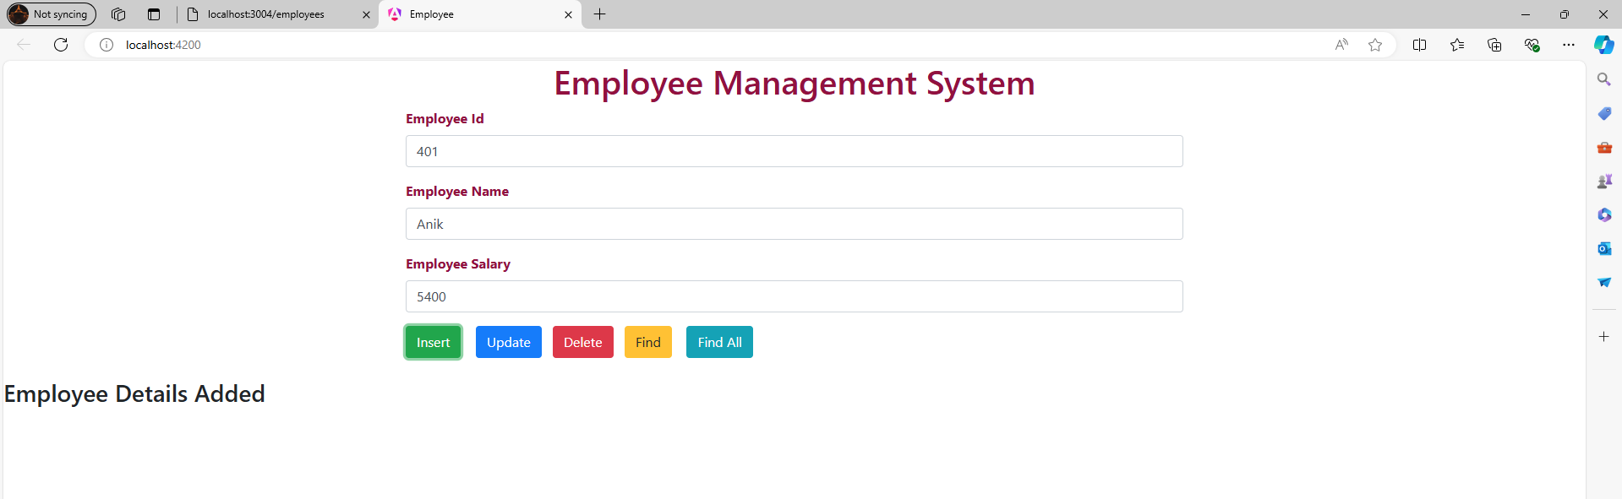

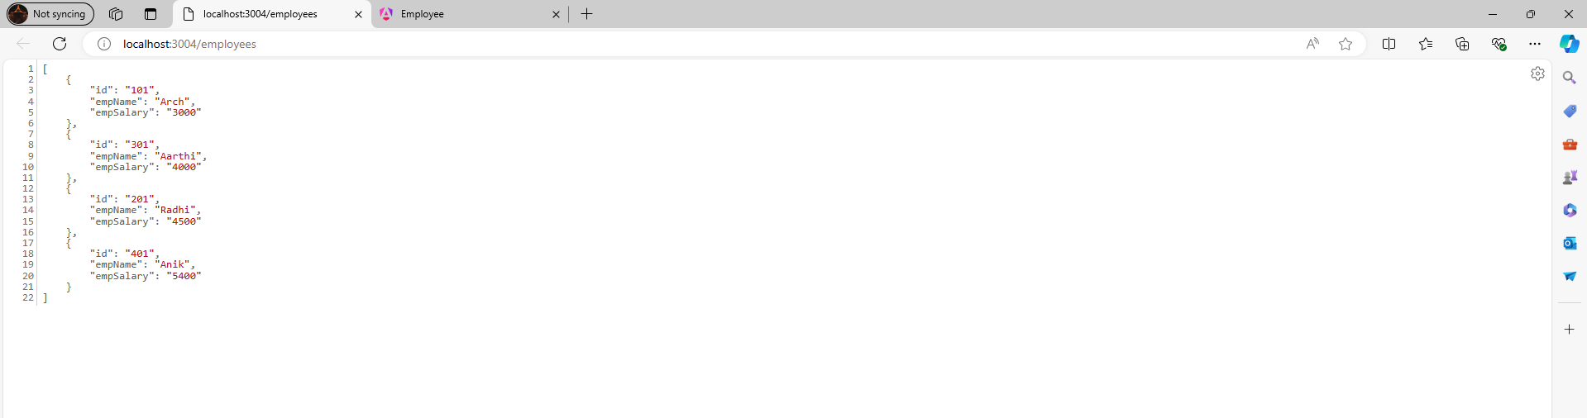

**UPDATE:**

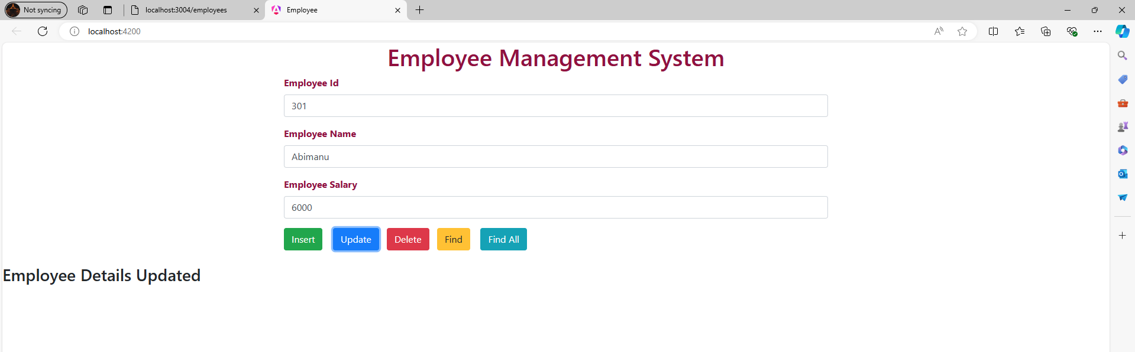

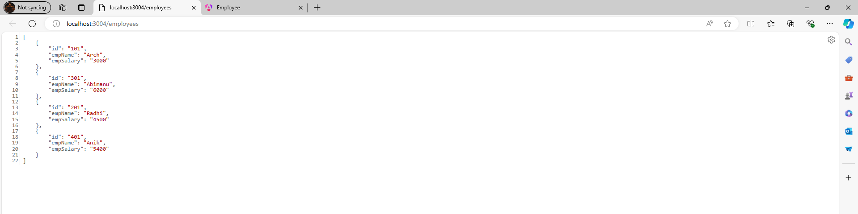

**DELETE:**

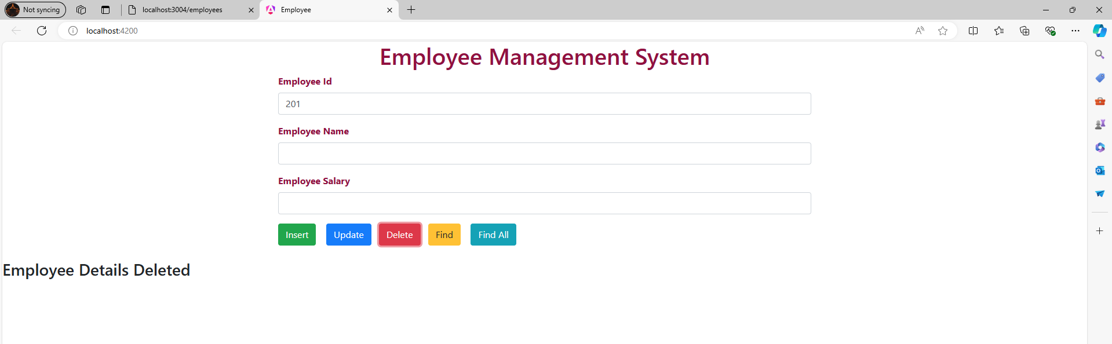

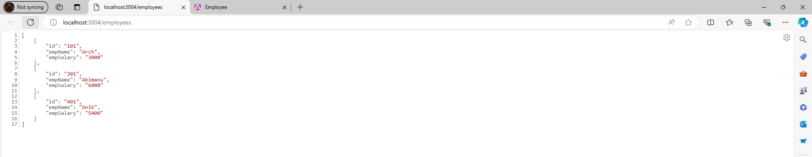

**FIND:**

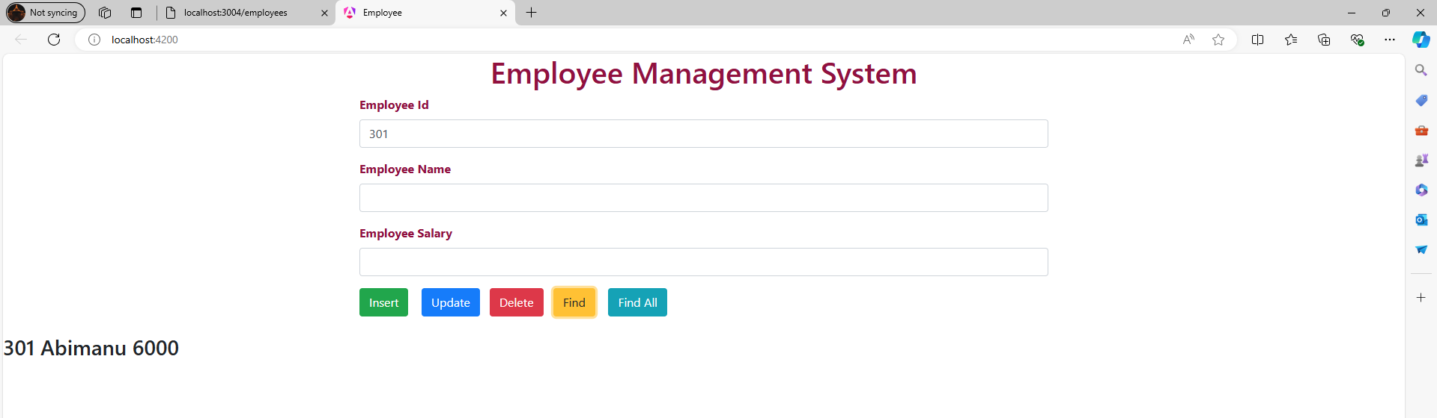

**FIND ALL:**

